Klondike Derby 2017
Hosted by Alpha Phi Omega – Phi Epsilon Chapter
Maine Maritime Academy

Greetings Scouters,

It is nearly time for Klondike Derby again! We look forward to seeing you all again and making this year bigger and better than the last. The 2017 MMA Klondike Derby will be Saturday, February 4th, 2017. There are two options to choose from regarding attendance.

OPTION 1:
Arrive Friday the 3rd any time after 5:00pm to register and spend the night in the
field house. Remember to bring appropriate sleeping bags and pillows because the college does not permit camping outside. Enjoy our pool, utilize the basketball courts and the rock wall, or watch a movie that Friday night when you arrive. In the morning, prior to the Klondike Derby, you will pack your overnight gear and be able to enjoy the Mess Deck for breakfast.

OPTION 2:
Arrive Saturday the 4th between 7:15 am – 8:15am to register. Please note that this option does not include breakfast at the Mess Deck or any time for other Maine Maritime Academy opportunities.

- Various scouting-related educational classes will be held Saturday morning (0845-1045) in (2) one-hour blocks.

- The Race will be held on Saturday afternoon.

- Patrols will break for lunch at 10:45am and everyone will head to a designated area where patrols will be able to start a small cooking fire and prepare a patrol lunch. This lunch will be a competition. The meals will be judging on nutrition, fire safety, Leave No Trace guidelines, creativity, taste (please leave a small sample available) and other factors. The materials for this meal will be provided by the troops. Store bought food (take out, frozen pizza, etc.) will not be judged. Be prepared because you only have 1 hour and 15 minutes for lunch. Please plan accordingly.

And to clear up any confusion, lunch is a scored event and counts toward the point totals for patrols. Patrols are responsible for finding the designated judges and getting their sign-offs.

- Sleds should be equipped with anything that may be needed. Be Prepared!
(i.e. pre-2015 Klondike Derby snowstorm for those who attended).
A few items that are mandatory: orienteering compasses, sleeping bag/blankets, first aid kit, fire starting equipment (matches, flint & steel, bow drill, tinder, wood, etc.), extra water, warm clothes. See the Gear List for full details.

- Saturday evening events will include a drill team demonstration, movie, celestial navigation demonstration, rock wall, patch trade, and possibly more.

- Sunday morning will consist of breakfast on the mess deck, followed by an optional tour of the Training Ship State of Maine.

For the Derby:
The briefing will be at 11:30 and the Derby will commence at 12:00. Patrols will use their compass skills and orient their way from station to station. Teams do not have to go to stations in a specific order (allowing teams to move ahead should there be a long wait time), however teams must complete each station before concluding the race and receiving their final time. The Derby will officially end at 17:00 (all sleds must be out of the woods by then). The scouts will return to the Mess Deck for dinner and then the Field House where they will unpack and change into appropriate clothing. At 19:00 we will hold an awards ceremony in Delano Auditorium. After the awards are distributed the evening events will commence.

Possible stations:
Patrols should prepare for Fire Building, Shelter Building, Knot Tying, First aid, Ice Rescue, Basic Scout Knowledge Trivia Questions, Orienteering, Plant Identification, and Cooking (for lunch on Saturday). (These are tentative and subject to change). Our Alpha Phi Omega – Phi Epsilon Brothers will be manning each station.

**Opportunity to help** Any Troop Leaders/Scoutmaster who would like to staff an above-mentioned station or have suggestions for different stations (preferably ones they’d be willing and able to assist us with) are encouraged to contact us. As always, we welcome input that would help better the event. If individuals have credentials to sign-off merit badges or partials that could be done during the course of the weekend, let us know.

Upon arriving to MMA:
Troops bringing trailers are asked to park in the Public Works lot (indicated in red to the left of the Logan Alexander Fieldhouse on the campus map). Other vehicles can park in the athletics lot between the football field and practice field.
------------------------------------------------------------------------------------------------------------
Monetary:

Regular registration (postmarked on or before January 23rd)
The cost for Friday night arrivals (includes Saturday breakfast) is: $ 35 /person
The cost for Saturday morning arrivals (Saturday. breakfast not included) is: $ 30 /person

Late registration (postmarked after January 23rd)
The cost for Friday night arrivals is: $ 40 / person
The cost for Saturday morning arrivals is: $ 35 / person
Race day (Saturday) registration $ 40 / person (can’t guarantee a patch)
The prices listed apply to both Scouts and Leaders (or other attendees).
------------------------------------------------------------------------------------------------------------
Please fill out the enclosed registration forms for your Troop and each Patrol, and return them to us as soon as possible. Make checks payable to Alpha Phi Omega – Phi Epsilon. Troops should keep a copy of medical forms for each Scout on hand in the event of an emergency throughout the weekend. These do not need to be turned in to APO personnel.

Refund Policy: As we must provide an estimated meal count to Sodexo Food Services one week prior to the event and that is the majority of the expense we cannot guarantee refunds.

We can’t wait to see everyone at the beginning of February! Feel free to contact us with any questions you have visit our website (www.apomainemaritime.weebly.com) where event updates and photos are posted along with info about the Phi Epsilon chapter.

Yours in Scouting,

Haley Eckert, Tyler Smith, Matthew Link – Klondike Chairs
Alpha Phi Omega – Phi Epsilon
Email: haley.eckert@mma.edu, tyler.smith@mma.edu, matthew.link@mma.edu

MMA 2016-2017 Parking Map

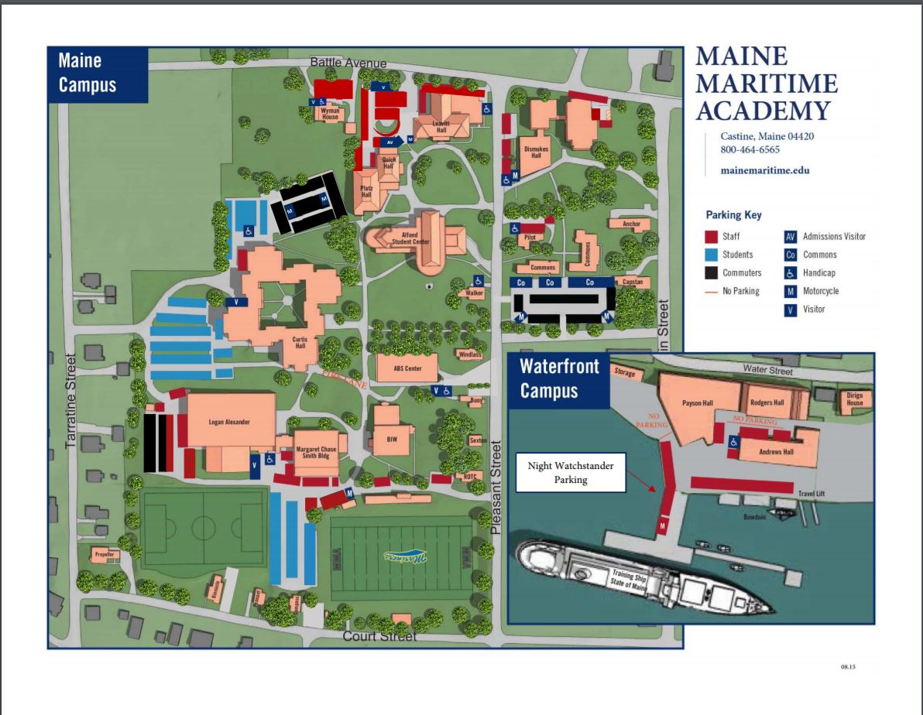

Campus Safety requests trailers be parked in the Public Works lot (the black section behind the Logan Alexander athletics building. Other vehicles may park in the blue student section between the football and practice fields.

Castine Klondike 2017
Gear List
Please ensure that the following gear is in your sled for the race:

- Orienteering Compass

- Sleeping Bag or Wool Blanket

- First Aid Kit

- Cooking supplies for lunch

- Lunch food

- Fire Starting supplies (matches, flint & steel, bow drill, tinder, etc.)

- Extra water

- Warm clothes

- Rope – suggested, but not required

Klondike Derby 2016
Hosted by Alpha Phi Omega – Phi Epsilon Chapter
Troop Registration Form (pg. 1 of 2)

Unit No:__________ Council:____________________ District:___________________
Address:__________________________________________________________________
City:______________________ State:__________ Zip:______________________
Contact Person:_________________________________ Position:__________________
Contact Telephone: (_____)_____________ Contact Email:_________________________
Dietary restrictions/allergies: yes □ no □ If yes, list: __________________________________________________________________________
__________________________________________________________________________
Other Adult Leaders Present: _________________________________________________
_________________________________________________
_________________________________________________
_________________________________________________
----------------------------------------------------------------------------------------------------------------
□ Friday evening arrival
# of Scouts and Scouters __________ x $_________/person = $_________________
□ Saturday morning arrival
# of Scouts and Scouters __________ x $_________/person = $__________________

Check #aa __________ Total payment owed = $__________________
-----------------------------------------------------------------------------------------------------------------
# of Patrols/Sleds: ______
Patrol Names: __________________________________________
__________________________________________
__________________________________________
__________________________________________
Return To:
Haley Eckert
ATTN: Klondike Committee
67 Pleasant Street, MMA Pilot House, Castine, ME. 04421

Klondike Derby 2016
Hosted by Alpha Phi Omega – Phi Epsilon Chapter
Patrol Registration Form (pg. 2 of 2)

Unit No:__________ Council:____________________ District:___________________
Patrol Name:__________________________________________________________________
Patrol Leader: ______________________________________________
Patrol Members: ______________________________________________
______________________________________________
______________________________________________
______________________________________________
______________________________________________
______________________________________________
______________________________________________
______________________________________________
Additional Patrols - Registration Form

Unit No:__________ Council:____________________ District:___________________
Patrol Name:__________________________________________________________________
Patrol Leader: ______________________________________________
Patrol Members: ______________________________________________
______________________________________________
______________________________________________
______________________________________________
______________________________________________
______________________________________________
______________________________________________
______________________________________________

Return To:
Haley Eckert
ATTN: Klondike Committee
67 Pleasant Street, MMA Pilot House, Castine, ME. 04421

